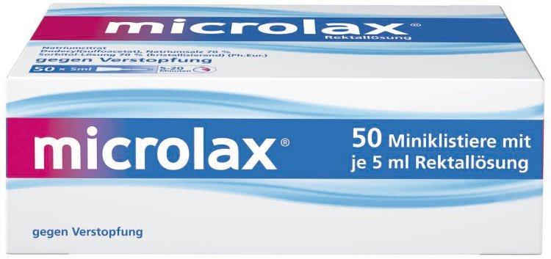
Sidebar: Here’s what frequent constipation sufferers have to say about MICROLAX®:
“MICROLAX® is my definitive little weapon against constipation.”
“MICROLAX® is really fast… it literally takes minutes to work.”
“As a constipation treatment it never fails.”
“I got rid of my constipation within 10 minutes of taking MICROLAX®…and I feel like I’ve really triumphed. I have beaten my constipation.”

A Wakeup Call and Growth Expansion for MICROLAX®
Winner of the James E. Burke Marketing Award for Scaled Best Practice.

MICROLAX®?
No. It’s not a tiny airport in Los Angeles.
Nor is it the world’s smallest wristwatch.

It’s a do-it-yourself enema that’s sweeping through Europe and Russia and ready to take on the world. Yet it’s not a new formula or an improved delivery system. The brand teams call it a “sleeping beauty” product that has finally woken up after being relatively dormant for over 50 years.

Simply put: MICROLAX® is a rectal application of liquids that causes one to have a bowel movement. The fact that it’s small – with an applicator holding only 5 ml of liquids – fast acting, and allows the user to DIY (do it yourself) controlling the timing in the privacy of their own bathroom – gives the product distinct advantages over its competitors. But until brand teams in France and Spain with the support of the GFO (Global Franchise Organization) figured out how to appeal to consumers by zeroing in on the product’s benefits, instead of its function… MICROLAX® was a real “sleeper.”

“Quite frankly,” says Jane Doe, Senior Director, Global Digestive Healthcare Franchise, “it wasn't appealing as a consumer product. We had convinced ourselves that it wasn’t worth promoting. We told ourselves that MICROLAX® wouldn’t sell and therefore wasn’t worth an investment of marketing dollars. But that story we told ourselves wasn’t true.”

Luckily brand managers in France and Spain had other ideas. It was 2008 when the Spanish brand team started to directly manage the product (called MICRALAX® in Spain) after the consumer business was acquired from Pfizer in 2006. “We realized that the product format offered a number of distinct advantages over oral laxatives that take many hours to work,” says John Doe, Head of Marketing, OTC, Spain and Portugal. “After two years of consumer research, we came up with a simple, but powerful insight revealing that people with constipation want a fast remedy that gives them control over when they ‘go’.” MICRALAX® needed to be re-framed with that in mind. So the local Spanish brand team came up with a local TV spot called “Underground” and saw immediate growth in their marketshare.

Around the same time the local French team started having significant discussions with their consumers about constipation. “When we thought about it, we realized that this product was rather unique,” says Jen Doe, Marketing Director, France. “With the insights we collected, we realized we were thinking about constipation as a pathology - a physical blockage in your gut, but we came to understand that constipation was a heavy emotional burden for our consumers. It hindered them in their mobility and weighed on their minds heavily until they could relieve themselves. So we worked with this emotional connection and produced a local TV commercial called ‘Rope.’” And again sales increased.
“It was around this time that their successes caught my attention,” says Jane. “The global franchise team started to wonder how we could get involved to help the two countries work together. We started thinking about ways to do this in more countries, and we started thinking about MICROLAX® as a regional brand.”
With their local insights, the French and Spanish teams (with the support of the GFO Global Franchise Organization) came up with new positioning for MICROLAX® as a laxative that provides "lightness of mind." Their advertising suggested that MICROLAX® frees your body of constipation, but also frees your mind, so you can get back to your life quickly. It was a message for on-the -go people, who needed to “go.”
Their current TV spot features a beautiful woman who “kicks the hands of time” liberating herself from constipation in under 20 minutes. Test runs of this commercial saw further uptick in sales.
Rollouts in other Countries
But the GSI didn’t stop there. Using a scaled, best practices approach, the team introduced this product to Germany, Russia, Sweden, and Finland with recent activations in Australia. It was a great help that the brand already was distributed and sold in EMEA. They just needed to market it differently (and smartly.)

“We took something that worked in one country and tried to apply it as broadly as we could,” says Jane, “and that thinking won us the Burke Award.”

And over-all, this application of scaled best practices drove significant growth in 2013, achieving an increase of +20.7% in all markets combined and delivering +9.6% over business plan, attaining record marketshare in Russia, Spain and Finland. And they won’t stop there. The franchise plans to continue their investment and apply these best practices as they activate in even more countries with a goal of becoming a much bigger player globally.

“This was our “sleeping beauty” – a funny thing to call an enema, but that’s what we all call it,” laughs Jane in conclusion. “I really appreciate that we invested in this small brand and “woke it up.” And so far it’s a happy ending for every country. We look to the left and we look to the right. It’s all about learning from others.”

